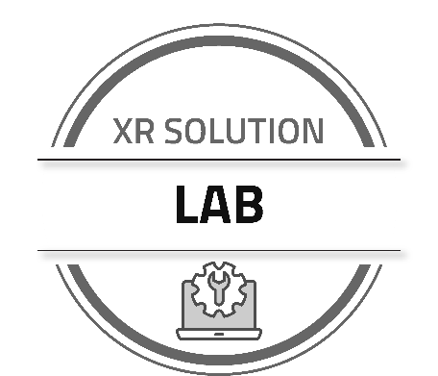

Lab 1: Register and Explore

LAB SUBMISSION
Name: <type your name here>
Email: <type your email here>

As you proceed through the lab exercise, copy and paste the appropriate screenshots into this document. When complete, log into the Sierra Wireless training portal, access the training session, and upload this saved document. This lab exercise is due before the start of the week 2 training.

Register your XR Series router in ALMS

Screenshot #1
Shows ALMS account name, Comm status in green, Sync status in green, Router serial number
<paste screenshot here>

Connect and log into your XR Series router via Ethernet

Screenshot #2
Shows the IPv4 and IPv6 tables and current WAN connection states. The screenshot must show both tables.
<paste screenshot here>

Set basic configuration parameters in AirLink OS
Screenshot #3
Shows the Dashboard, showing WAN states (Cellular, Wi-Fi, Ethernet) and LAN states (Wi-Fi, Ethernet most likely)
<paste screenshot here>

Screenshot #4
Shows the Neighbor table with active connections
<paste screenshot here>

